

Lab Journal: 5
Date: 28/10/2023

Student: Abdul Rafay Abbasi
Enrollment: 01-131232-005

Computer Programming Lab (Fall-2023)
Teacher: Engr. M Waleed Khan

Department of Software Engineering

Bahria University, Islamabad

Task No: | Task Wise Marks |  | Documentation Marks |  | Total Marks  (20)
Task No: | Assigned | Obtained | Assigned | Obtained | Total Marks  (20)
1 | 3 |  | 5
2 | 3 |  | 5
3 | 3 |  | 5
4 | 3 |  | 5
5 | 3 |  | 5

Comments:

Signature

Lab No: 5- DO-WHILE LOOP

Introduction

Loops are repetitive structures and we use them if we want to repeat a particular set of statements

in a particular way. There are three variants of loops used:

• For Loop

• While Loop

• Do-While Loop

Tools Used
Visual Studio

Task 1:
Write a program to print in the descending order first twenty natural numbers on the computer
screen by using “do-while” loop.

Code
#include<iostream>
using namespace std;
int main()
{
int i=20;
do
{
cout << i << endl;
i--;
} while (i >= 1);
system("pause");
return 0;
}

Screenshot
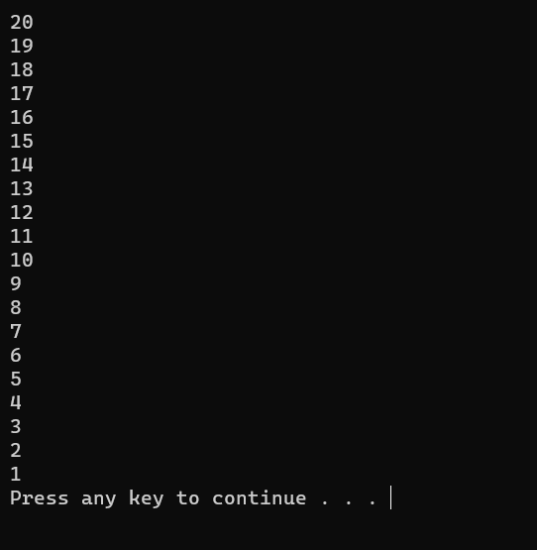

Task 2:
Write a program to compute and print the factorial of the given number using the “do-while”
loop.

Code

#include<iostream>
using namespace std;
int main()
{
int i;
int n;
long f = 1;
cout << "Enter Your Number: ";
cin >> n;
int x = n;
do
{
f = f * n;
n--;
} while (n > 1);
cout << "Factorial is: " << f << endl;
system("pause");
return 0;
}

Screenshot

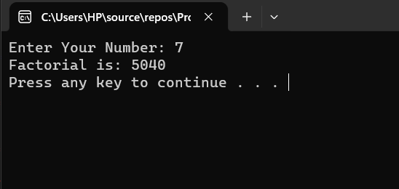

Task 3:
Write a program to convert the given decimal number into octal number using the “do-while”
loop.

Code
#include<iostream>
using namespace std;
int main()
{
int n;
cout << "Enter your Number: ";
cin >> n;
int x;
int z = 0;
int p=1;
cout << endl;
if (n > 0)
{
do
{
x = n % 8;
z += x * p;
n /= 8;
p *= 10;
} while (n != 0);
cout << "Ocatl Representation is: "<< z << endl;
}

else
{
cout << "Invalid Entry \n";
}
system("pause");
return 0;
}

Screenshot
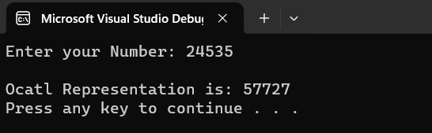

Task 4:
Create the equivalent of a four-function calculator. The program should request the user to enter
a number, an operator, and another number. (Use floating point.)
It should then carry out the specified arithmetical operation: adding, subtracting, multiplying, or
dividing the two numbers. Use a switch statement to select the operation. Finally, display the
result.
When it finishes the calculation, the program should ask if the user wants to do another
calculation. The response can be ‘y’ or ‘n’.

Code

#include<iostream>
using namespace std;
int main()
{

int n1;
char operation;
int n2;
char another;

do {
cout << "\nEnter Your First Number: ";
cin >> n1;
cout << "\nEnter Operator : ";
cin >> operation;
cout << "\nEnter Your Second Number: ";
cin >> n2;
switch (operation)
{
case '+':
cout << "Result: " << n1 + n2 << endl;
break;
case '-':
cout << "Result: " << n1 - n2 << endl;
break;
case '*':
cout << "Result: " << n1 * n2 << endl;
break;
case '/':
if (n2 != 0)
{
cout << "Result: " << n1 / n2 << endl;
}
else
{
cout << "Undefined\n";
}
}
cout << "Do you want to make another calculation (y/n)? \n";
cin >> another;
cin.ignore();
if (another == 'n' || another == 'N')
exit;
else
{
cout << "Invalid Entry";
}
} while (another == 'Y' || another == 'y');

cout << endl;
system("pause");
return 0;
}

Screenshot
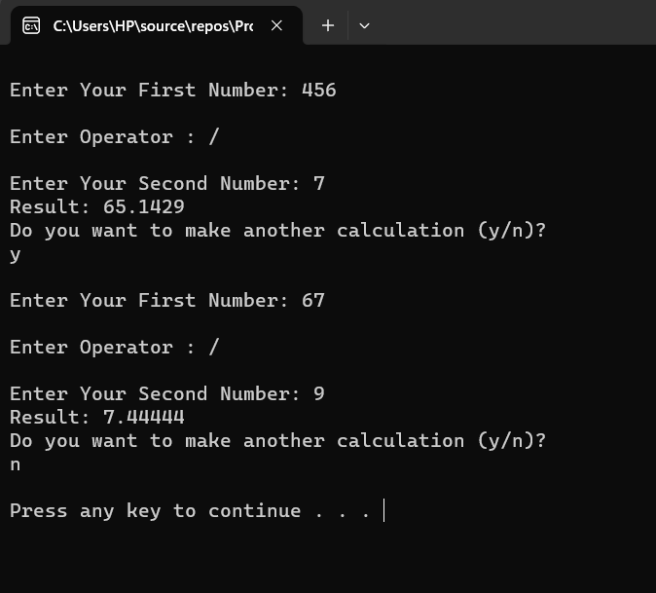

Extra Tasks

Task 1:
It is necessary for the program to display the following sequence of numbers:
7 14 21 28 35 42 49 56 63 70 77 84 91 98

Code
#include<iostream>
using namespace std;
int main()
{
int n = 7;
int x = 1;
int sum = 0;
do
{

cout << n * x << " ";
x++;
} while (x <= 14);
cout << endl;
system("pause");
return 0;
}

Screenshot

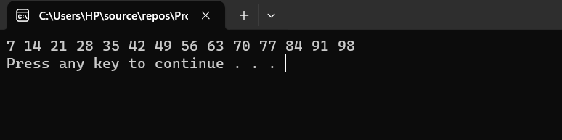

Task 2:
It is necessary to display the following sequence of numbers:
1 2 4 8 16 32 64 128 256 512

Code
#include<iostream>
#include<math.h>
using namespace std;
int main()
{
int n=0;
int mul = 1;
do
{
mul = pow(2,n);
cout << mul << " ";
n++;

} while (n <= 9);
cout << endl;
system("pause");
return 0;
}

Screenshot
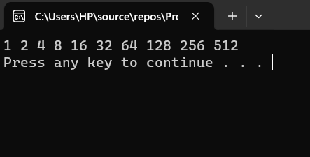

Conclusion
Understanding of basic concept of do-while loop. In “do-while” loop, the body of loop comes before
the test condition. The body of the loop is executed and then the condition is test

Lab Journal Instructions:
- This is the template file you need to follow for your Lab Journals
- The cover page is mandatory for every lab journal
- Fill the details accordingly don’t change any details regarding the university, department, course, or teacher.
- Fill your name and enrollment number accordingly
- Kindly provide the date on which the lab was held
- Lab Journal: followed by the number of lab and incase of open-ended add “Open-Ended” if it doesn’t fits reduce the font size a bit.
- Add or remove the rows in the evaluation table based on the number of tasks assigned in the lab also fill the task number column.
- You are not supposed to fill the evaluation columns in the evaluations table apart from the task numbers. The same instruction is applicable for the comments section.
- These instructions are for your reference only no need to add them to the actual document.
- Update the page headers accordingly.
- Lab journal headings are provided above.
- Kindly follow the heading titles and styles set in the template and used justified text for paragraphs.
- In case the code is too long only add the key logic snippets and make sure your screenshots are clearly visible and readable.

